Project BUS O/D Matrix - September 2019

Technical Document

Contents

Revisions Table 3
SOFTWARE 4
How to install / use GPS 4
HARDWARE 5
Power supply 5

Revisions Table

2019-09-15 | Nuno | Added power supply schematics and configuration
2019-09-15 | Nuno | Added some software install and setup procedures
2019-09-12 | Nuno | Created doc and added GPS info

PC Setup

- Install Ubuntu 18.04
- Configure wireless access to 5A network
- Set User / password “o” / Automatic Login
- Disable Power -> Display Off
- Install Remote Access Software (VNC?)
- XXXXXXXXXXXXXXXXXXXX ()
- Install CUDA 10.1 ????? ()
- XXXXXXXXXXXXXXXXXXXXXXX

SOFTWARE

How to install / use GPS

1. Install PIP

$ sudo apt update
$ sudo apt install python3-pip

2. Install Pyserial

$ pip3 install pyserial

3. Change dev/ttyUSB0 speed to 4800 baud (as root)

# stty -F /dev/ttyUSB0 ispeed 4800

4. Read port in command line (as root)

# cat /dev/ttyUSB0

5. Python script

#Script to read USB GPS data directly from port - by Nuno Vieira
#Pyserial must be installed first

import serial

with serial.Serial('/dev/ttyUSB0', 4800, timeout=1) as ser:
latitude = ''
longitude = ''
while True:
line = ser.readline().decode('ascii', errors='replace')
if "GPGGA" in line.strip():
print(line.strip())
time,lat,dir1,longi,dir2,qual,sats = line.strip().split(",")[1:8]

print("UTC time: "+time[0:2]+":"+time[2:4]+":"+time[4:6])
print("Latitude: " + lat + " " + dir1)
print("Longitude: " + longi + " " + dir2)
print("Used satellites: " + sats)
print()

#1 = UTC of Position
#2 = Latitude
#3 = N or S
#4 = Longitude
#5 = E or W
#6 = GPS quality indicator (0=invalid; 1=GPS fix; 2=Diff. GPS fix)
#7 = Number of satellites in use [not those in view]
#8 = Horizontal dilution of position
#9 = Antenna altitude above/below mean sea level (geoid)
#10 = Meters (Antenna height unit)
#11 = Geoidal separation (Diff. between WGS-84 earth ellipsoid and
# mean sea level. -=geoid is below WGS-84 ellipsoid)
#12 = Meters (Units of geoidal separation)
#13 = Age in seconds since last update from diff. reference station
#14 = Diff. reference station ID#
#15 = Checksum

HARDWARE

Power supply

M2 - 140W

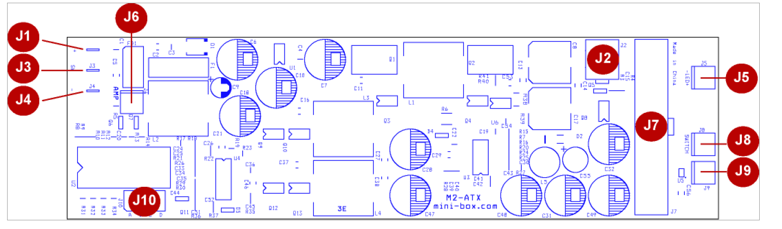

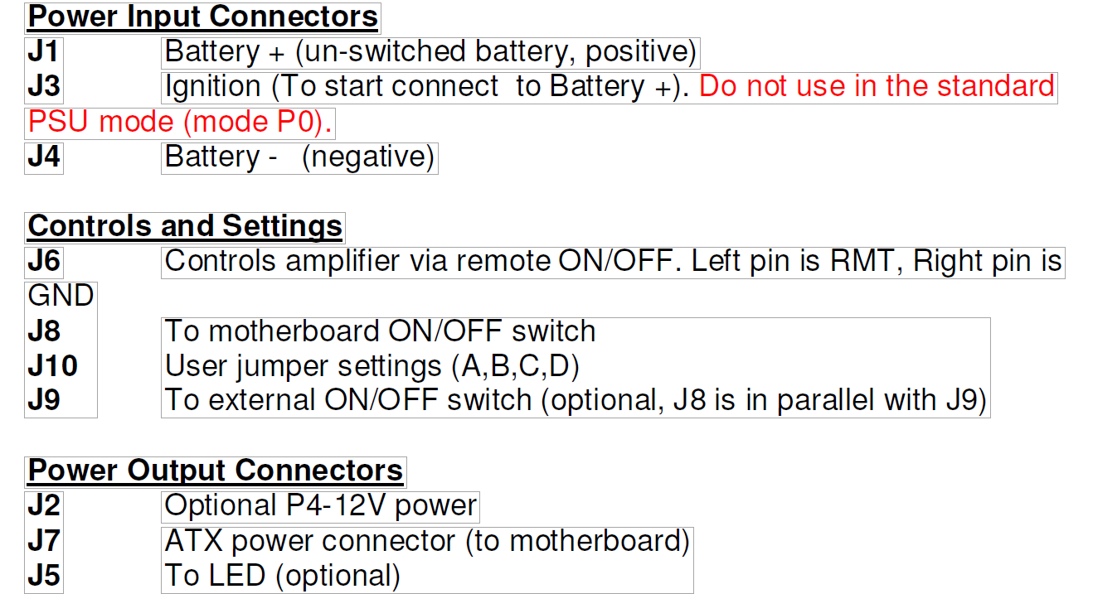
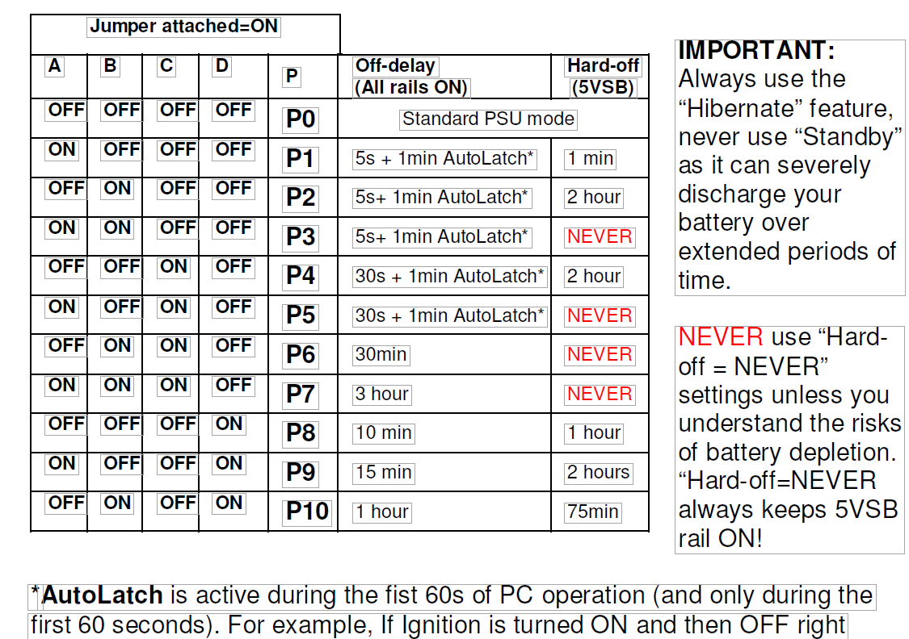

M4 – 220W

